CHAPTER THREE
METHODOLOGY AND SYSTEM ANALYSIS

3.1 Methodology Adopted
A software development methodology is a structured framework used to plan, manage, and control the process of developing an information system. For the design and implementation an Online Ticket Reservation System for Lagos State Transport Company, selecting the right methodology is critical to ensure the system meets both the operational needs of the transport managers and the usability expectations of daily commuters.

3.1.1 Overview of Considered Methodologies

1. SSADM - Waterfall Methodology
The Waterfall model is a traditional, linear, and sequential approach to software design. Progress flows steadily downwards (like a waterfall) through distinct phases: Requirements gathering, Design, Implementation, Verification (Testing), and Maintenance.

- Strengths: It is highly structured, strictly documented, and easy to manage because each phase has specific deliverables and a review process.

- Weaknesses: It is highly inflexible. Once a phase is completed, it is difficult and costly to go back and make changes. It also delays user testing until the very end of the development cycle, which is risky for user facing applications.

2. Prototype - Rapid Application Development (RAD) Methodology
RAD is an adaptive software development model that prioritizes rapid, rigorous planning. It involves developing iterative prototypes that are quickly shared with the client for evaluation.

- Strengths: Reduces development time significantly and ensures high user involvement, meaning the final product is heavily tailored to the user's visual and functional preferences.

- Weaknesses: It can sometimes lead to poor underlying system architecture because the focus is on building the front-end quickly. It also requires a highly skilled development team to execute rapidly.

3. OOAD - Agile Methodology
Agile is an iterative and incremental approach that breaks the development process into smaller, manageable cycles called "sprints" (usually lasting 2 to 4 weeks). Each sprint involves cross-functional teams planning, designing, coding, and testing a specific piece of the software,
in a continuous release of usable features.

- Strengths: Extremely flexible to changing requirements, promotes continuous improvement, and ensures early delivery of a functional system. Stakeholder feedback is integrated throughout the process.

- Weaknesses: Requires active and continuous communication. The project scope can easily expand (scope creep) if not properly managed.

3.1.2 The Adopted Methodology: Agile
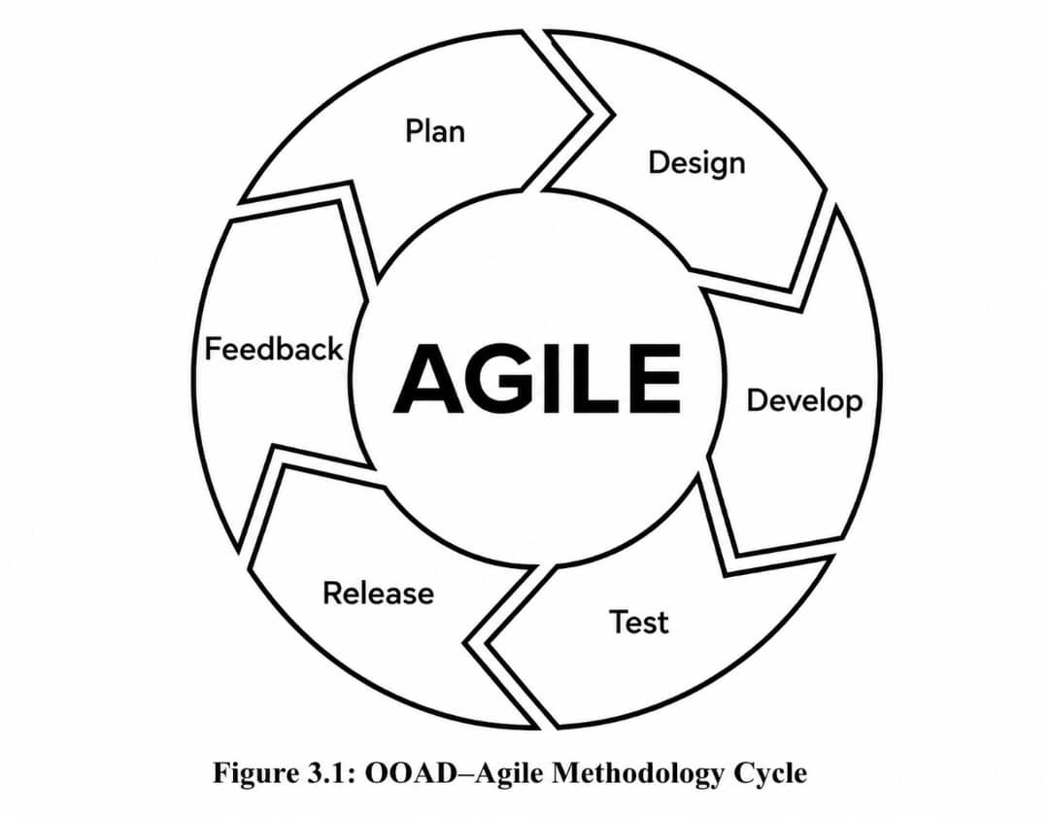

For the design and implementation of an online ticket reservation system for Lagos State Transport Company, the Agile Methodology is the adopted approach.

Justification for Adopting Agile:

- Adaptability to the Lagos Transport Ecosystem: The public transportation landscape in Lagos is highly dynamic. Requirements regarding ticketing routes, pricing models, or boarding terminals may change during development. Agile allows the development team to pivot and update these requirements without derailing the entire project.

- Iterative Delivery of an MVP: Using Agile, the project can first launch a Minimum Viable Product (MVP) such as basic route viewing, seat selection, and a secure payment integration (e.g., Paystack or Flutterwave). Subsequent sprints can then introduce advanced features like QR code generation, SMS ticket notifications, and admin analytics dashboards.

- Continuous Stakeholder Feedback: A ticketing system serves two distinct groups: the commuters (who need a simple, mobile-friendly interface) and the transport administrators (who need complex fleet and revenue management tools). Agile ensures that prototypes and beta versions are continuously tested by
- Risk Mitigation: By testing the system incrementally during each sprint, critical bugs (such as payment gateway failures or double-booking of a single seat) are identified and resolved early, rather than discovering them at the final launch stage.

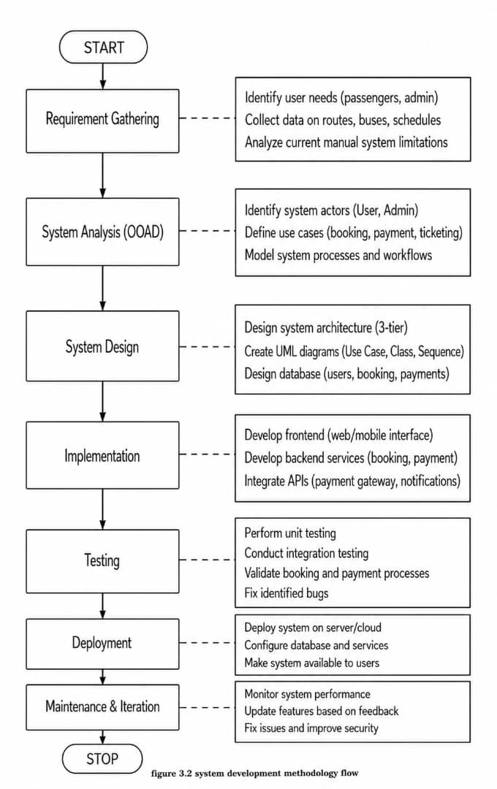
3.2 System Analysis
System analysis is the process of studying and understanding the requirements of a system before its development. It involves identifying system users, defining system processes, and determining how data flows within the system.
In this project, two main users are identified: the customer and the administrator. The customer interacts with the system to perform activities such as registration, searching for available buses, booking tickets, making payments, and downloading tickets. The administrator, on the other hand, manages the system by controlling bus schedules, user data, and generating reports.
System analysis also considers the inputs, processes, and outputs of the system. Inputs include user details and travel information, processes include booking and payment handling, while outputs include tickets and reports.

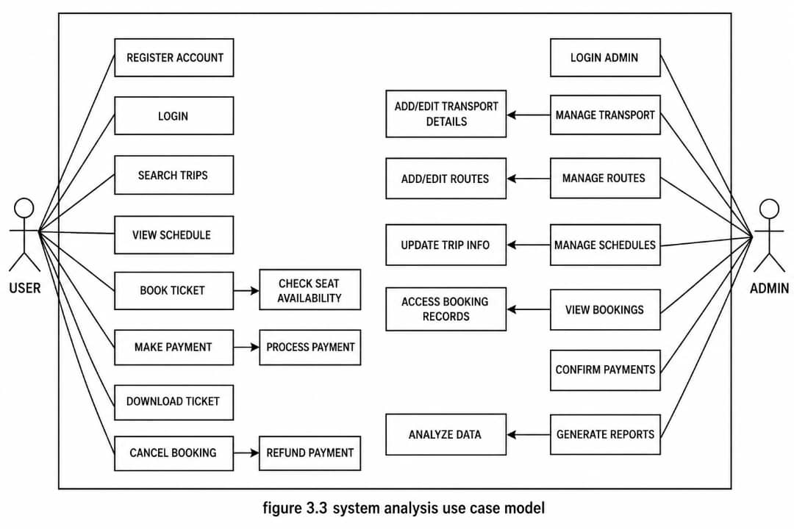

3.3 Analysis of the Existing System
The existing system for bus reservation in many parts of Nigeria is largely manual or semi-automated. Passengers are required to physically visit bus terminals to make inquiries, book tickets, and complete payments.
This system involves several steps, including checking for bus availability, filling out booking forms, making cash payments, and collecting paper tickets. While this method has been in use for many years, it is inefficient and time-consuming.
The manual nature of the system often leads to long queues, delays, and errors in record keeping. Additionally, it does not provide users with the convenience of remote access or real-time updates.
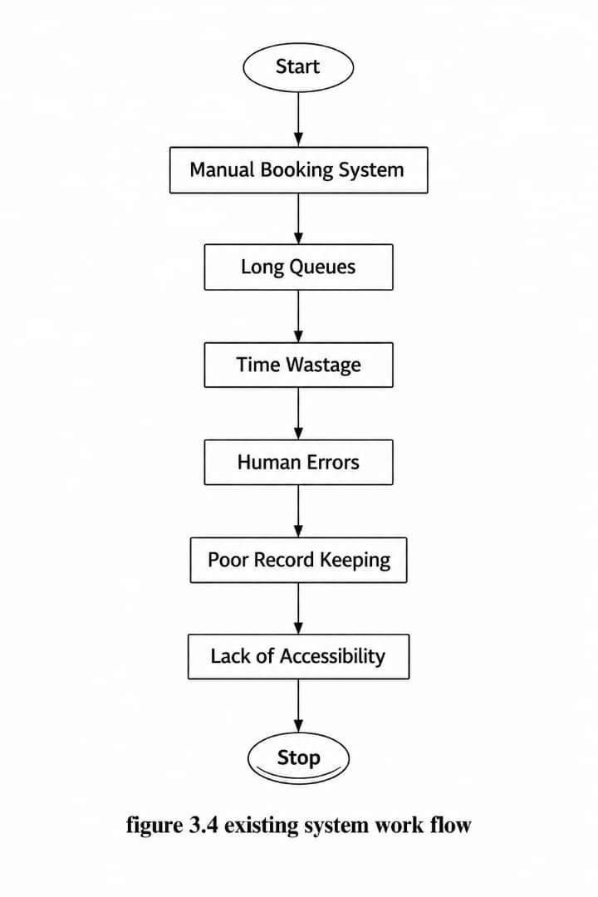

3.4 Weakness of the Existing System
The existing manual system has several weaknesses that affect both passengers and transport operators.
Here are the key weaknesses typically found in the existing system:

1. Physical Presence Requirement
The most significant drawback is the necessity for commuters to be physically present at the terminal to purchase tickets. This leads to:

- Crowding and Congestion: Excessive physical queues at ticket counters, especially during peak hours (morning and evening rushes).

- Time Inefficiency: Commuters waste valuable hours traveling to the park only to find that tickets for their preferred time slots are sold out.

2. Lack of Real-Time Seat Inventory
Manual systems often struggle with synchronized data management across different terminals.

- Double Booking: Without a centralized database, there is a high risk of the same seat being sold to two different passengers at different loading points.

- Inaccurate Scheduling: Passengers have no way of knowing if a bus is delayed or canceled until they arrive at the station, leading to poor travel planning.

3. Revenue Leakage and Financial Lack of Transparency
Manual ticketing relies heavily on paper receipts and cash handling, which creates several vulnerabilities:

- Human Error: Mistakes in manual calculations and physical record-keeping.

- Security Risks: Handling large volumes of cash at terminals increases the risk of theft or internal misappropriation.

- Difficult Auditing: Generating comprehensive financial reports is labor-intensive and prone to manipulation when records are kept in physical ledgers.

4. Limited Payment Flexibility
The existing system is often restricted to cash-only transactions. This is increasingly problematic in a growing "cashless" economy where:
- Commuters prefer using POS, bank transfers, or mobile wallets.

- The lack of digital payment integration prevents the transport company from capturing a wider market of tech-savvy travelers.

5. Poor Data Management for Strategic Planning
Because data is often fragmented or paper-based, the management lacks actionable insights.

- No Customer History: It is nearly impossible to track frequent travelers or implement loyalty programs.

- Inflexible Resource Allocation: Without digital analytics, it is difficult to identify which routes are over-served or under-served, making it hard to optimize the deployment of the bus fleet.

3.5 Analysis of the Proposed System
The proposed system is an online bus reservation system designed to overcome the limitations of the existing system. It is a web-based platform that allows users to perform all booking activities online.
With the proposed system, users can register, search for available buses, select seats, make secure payments, and receive electronic tickets. The system also provides real-time updates on bus schedules and availability.
The administrator has access to manage routes, transport, users, and generate reports. The system also integrates a payment gateway to handle online transactions securely.
This system improves efficiency, reduces manual effort, and enhances user experience.
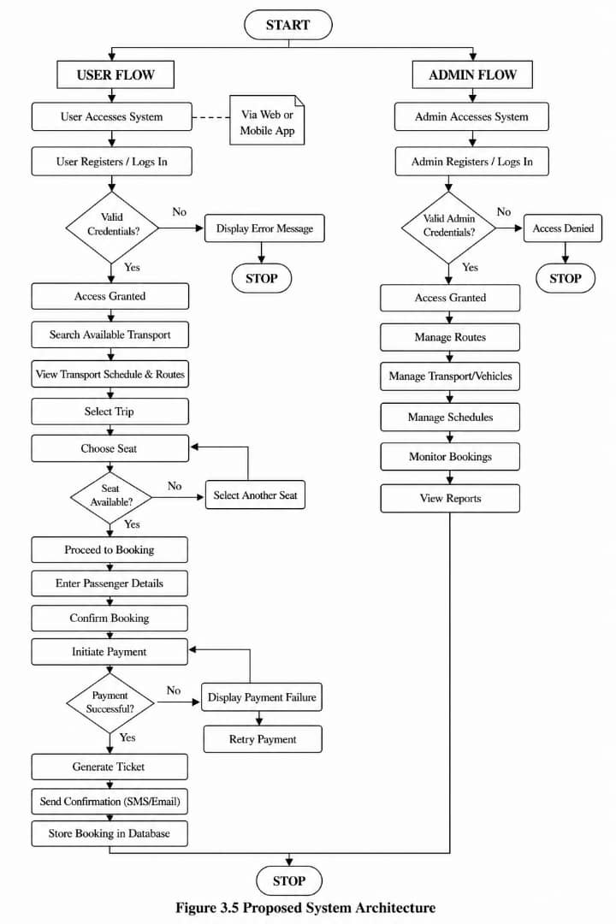
3.5.1 System Process Flow
The system process flow defines the logical sequence of activities and interactions between the users and the system. In the context of the Lagos State Transport Company, the process is designed to be lean and high-speed to accommodate the high volume of daily commuters. This flow transitions the traditional manual terminal operations into a digital environment, categorized into three primary phases: Authentication, Transaction, and Fulfillment.
3.6 Advantages of the Proposed System
The proposed online ticket reservation system addresses the inherent weakness of the manual process by introducing automation, transparency, and accessibility. By shifting the architecture to a centralized digital platform, the Lagos State Transport Company can achieve the following advantages:

1. Enhanced User Convenience and Accessibility
The most immediate benefit is the elimination of geographical barriers for commuters.

- 24/7 Booking: Passengers can reserve seats at any time from their mobile devices or computers, removing the need to travel to the terminal prematurely.

- Real-Time Information: Users can view available routes, departure times, and seat layouts in real-time, allowing for better personal scheduling.

2. Improved Operational Efficiency Automation reduces the administrative burden on transport staff and streamlines terminal operations.

- Centralized Database: A unified system prevents double-booking by instantly updating seat inventory across all access points the moment a transaction is completed.

- Automated Manifest Generation: Passenger manifests can be generated instantly, reducing the departure delays caused by manual paperwork.

3. Financial Transparency and Security
Moving toward a digital payment ecosystem significantly secures the company's revenue streams.

- Multiple Payment Gateways: Integration with bank transfers, cards, and USSD provides flexibility for the user while ensuring funds are deposited directly into corporate accounts.

- Elimination of Leakage: Digital records are harder to manipulate than paper ledgers, making auditing more accurate and reducing the risks associated with handling large amounts of physical cash at the parks.

4. Data-Driven Decision Making
The proposed system acts as a repository for valuable business intelligence.

- Traffic Analytics: Management can identify peak travel periods and high-demand routes, allowing them to deploy more buses where they are needed most.

- Customer Retention: The system can store passenger preferences and history, enabling the company to implement loyalty programs or targeted discounts to improve customer satisfaction.

5. Scalability and Integration
Unlike a manual system, a digital framework is built to grow with the city's infrastructure.

- Future-Proofing: The platform can easily be integrated with other Lagos State transport initiatives, such as the Cowry card system or multi-modal transit tracking.

- Resource Optimization: By knowing passenger loads in advance, the company can optimize fuel consumption and vehicle maintenance schedules.

The proposed system offers numerous advantages over the existing manual system. One of the key benefits is convenience, as users can access the system from anywhere at any time.

3.7 High-Level Model of the Proposed System

3.7.1 The high-level model of the proposed system describes how different components interact with one another. The system consists of the user interface, application server, database, payment gateway, and admin panel.
